

LOVELY PROFESSIONAL UNIVERSITY

PUNJAB

**Session :- 2019-20**

Final Report For CSE 326 Project - Website Design.

Project Title :- Online Train/Flight Reservation System.

Section :- K19HA (Group 2)

Submitted To :- Ms. Manu Bali

__________________________________________________

* Group Members

|  |  |  |  |
| --- | --- | --- | --- |
| **Sr. No** | **NAME** | **Roll no.** | **Registration No.** |
| 1 | Gulamajji Pavan Kumar | RK19HAB54 | 11909666 |
| 2 | Sanish Nirwan | RK19HAB55 | 11909672 |
| 3 | Ayush Kumar Pal | RK19HAB56 | 11909560 |

__________________________________________________

Contents

* Introduction
* Description of Project
* Implementation Of HTML in project
* Implementation Of CSS in project
* Implementation Of JavaScript in project
* Organizational Chart Illustration for validating Sign Up Criteria
* Output Screen of the Webpage.
* Contribution Of Group Members in project

Introduction

Purpose of allotment of this project to our group is to get the brief idea about concepts of development of webpage using various programming such as HTML 5, CSS and Javascript (JS).

In this project, we will utilize and use this languages to develop a webpage for setting up a webpage for Online Train/Flight Reservation System.

Advantage of this type of Train reservation portals are these, Online Train reservation portals makes it easier to book or cancel tickets without consuming much time. They are convenient and saves efforts. Also they are medium to ensure every need of a passenger to complete his/her journey with comfort. They also provide options for booking meals and to check train status.

Description of project

* Programming Languages Used :-

* Webpage Development Platform :-

Implementation Of HTML in project

In the project, we had used HTML to make up the layout and structure of our webpage. We used its various tags and attributes to mould our code to a functional webpage.

Some of the tags and attributes we have used in our projects are :-

**Tags** :-

1. *<!DOCTYPE...>* : This tag defines the document type and HTML version.
2. *<html>* : This tag encloses the complete HTML document.
3. *<head>* : This tag represents the document's header which can keep other HTML tags like <title>, <link> etc.
4. *<title>* : The <title> tag is used inside the <head> tag to mention the document title.
5. *<body>* : This tag represents the document's body which keeps other HTML tags like <h1>, <div>, <p> etc.
6. *<h1>* : This tag represents the heading inserted in HTML document.
7. *<p>* : This tag is used for formatting text as paragraph content.
8. <b> : Bolds the text enclosed within this tag.
9. *<div>* : Containers used to label a page section or the placement of an element.
10. *<br>* : Anything following this tag starts from the next line.
11. *<hr>* : Horizontal lines are used to visually break-up sections of a document.
12. *<center>* : This tag is used to put any content in the center of the page or any table cell.
13. *<pre>* : This tag is used to preserve the formatting of the source document.
14. *<img />* : This tag is used to display image files.
15. *<ul>* : Bullet point list (Unordered list).
16. *<li>* : Specifies each item to be bulleted.
17. *<form>* : This tag is used to create a form in HTML script.
18. *<input/>* : This tag shows what type of field information to receive from users.
19. *<table>* : These tags define all the content related to a table.
20. *<tr>* : Content within a single row in a table.
21. *<th>* : The data in a single header item.

**Attributes** :-

* **align** : Horizontally aligns tags.
* **bgcolor** : Places a background color behind an element.
* **width** : Specifies the width of tables, images, or table cells.
* **height** : Specifies the height of tables, images, or table cells.
* **src= ”url”** : The URL or file name of image being displayed.
* **border** : Species border thickness.
* **placeholder** : This attribute specifies a short hint that describes the expected value of an input field.

Implementation Of CSS in project

While making up the webpage it was necessary to apply an appropriate background image for the webpage to make it look more attractive. But however with the HTML, it was not possible to get completely control over the set up of background image due to unspecific resolution of image file. With the help of CSS, we can easily get control over the behaviour of background like adjustment of background image with change of tab size, adjusting opacity of background, and preventing the background image from repeating after certain stances in web document, etc.

We have used external stylesheet linked with our main document, and we have configured the background image behaviour in the same stylesheet (extension - .css).

Implementation Of JavaScript in project

In this project we have used JavaScript in order to validate the basic information of the user such as phone number, E-mail address, password’s minimum length,etc.

Sometimes user may face it difficult to understand the guidelines to fill an online form, so to provide and assistance to the user in filling Sign In details in our project, we have set up certain parameters using appropriate algorithms through which we can show warning in case the user fills in some irrelevant or wrong type of input in Sign in details.

Talking about the JS algorithm in webpage, we have made a function through which it has been further used for validating the typed-in information. In the function we have applied if-else if conditions to check the passing of user input onto the standard of coded parameters.

Organizational Chart Illustration for validating Sign Up Criteria

When all the above criteria will be passed user will be automatically redirected to the page where he/she will be shown the confirmation for registering at the E-Portal of Railways.

Output Of the HTML Program

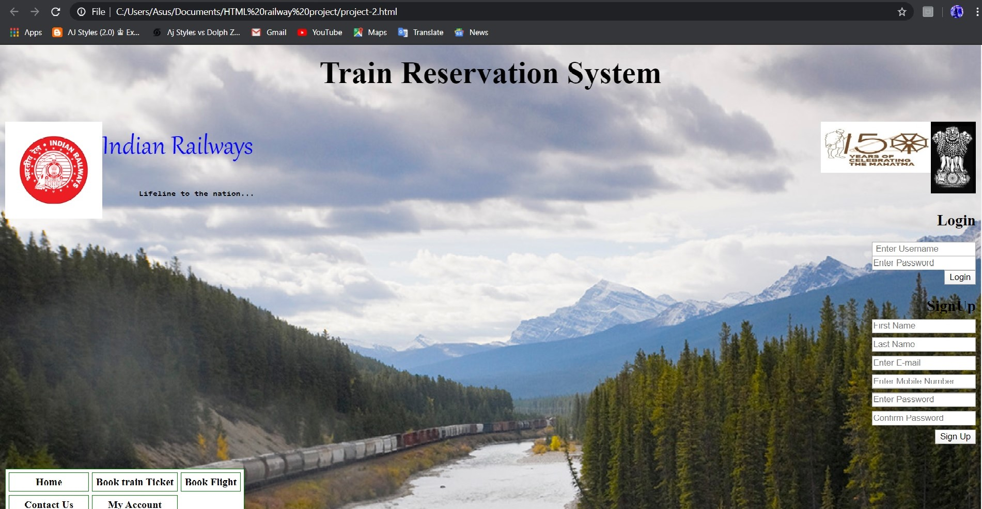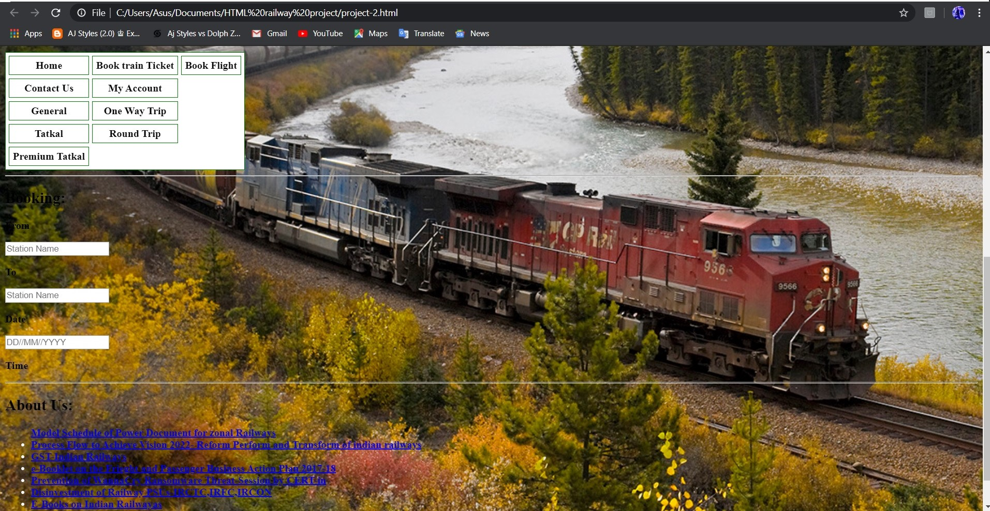

Contribution Of The Group Members In the Project

1. Gulamajji Pavan Kumar :- Roll no. - RK19HAB54 :- Registration no. :- 11909666 :-- Gave assistance in making final report and organizing images and other media for project.
2. Sanish Nirwan :- Roll no. - RK19HAB55 :- Registration no. :-11909672 :-- Implemented CSS and JavaScript section of the project and made the final report.
3. Ayush Kumar Pal ;- Roll no. - RK19HAB56 :- Registration no. :- 11909560 :-- Implemented HTML section of the program and made the synopsis for project.

Thank You !!!